KẾ HOẠCH DẠY HỌC KHỐI 9 NĂM HỌC 2021-2022
TUẦN 4 (27/09 – 02/10)
Tiết | Nội dung
5 | Unit 2: Clothing  Objective: By the end of the lesson, students will be able to know some more about AO DAI, the traditional dress of Vietnamese women.  Main focus:  I. Getting started  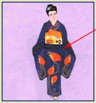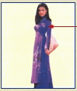  a, a kimono b, Ao Dai c, a kilt  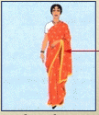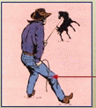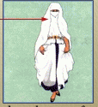  d, a sari e, jeans f, a veil  Questions:  Picture A :  T: Where is the woman in this picture from ?  S₁: She comes from Japan  T: How do you know she comes from Japan?  S₁: Because she is wearing a kimono.  b. She’s from Vietnam. She is wearing an Ao dai.  c. He’s from Scotland. He is wearing a kilt.  d. She’s from India. She is wearing a sari.  e. He’s from Western part of the USA. He is wearing a shirt and a pair of jeans.  f. She’s from an Islamic country. She is wearing a veil.  II. Listen and Read:  Vocabulary :  1. poet ( n ) : Nhà thơ  Ex: Nguyen Du, Huy Can are poets  2. a long silk tunic : áo lụa dài rộng  3. slit ( v ) : to make a long thin cut in something: xẻ  4. inspiration ( n ) : cảm hứng, hứng khởi  => take inspiration from something : lấy cảm hứng từ  5. ethnic minority : dân tộc thiểu số  Ex: Thai, Muong, Ede are ethnic minority people.  6. pattern ( n ) : ( picture ) hoa văn, họa tiết, mẫu  7. fashion ( n ) thời trang  => fashionable ( a ) : hợp thời trang, đúng mốt  8. unique (a) : độc đáo  9. loose pants : quần ống rộng  EX: They have mentioned the ao dai in poems, novels, and songs (The present perfect tense)  Structures :  The present perfect tense :  - Form : S + has / have + V₃/ V-ed  a) Complete the sentences. Use the information from the passage:  1 . For a long time the ao dai has been the subject of poems, novels and songs.  2 . The Ao dai is described as a long silk tunic with slits up the sides worn over loose pants.  3 . The majority of Vietnamese women prefer to wear modern clothing at work.  4 . Some designers have modernized the Ao dai by printing lines of poetry on it.  5 . Another alternative is to add symbols such as suns, stars, crosses and stripes.  b) Answer the questions:  1 . Traditionally, men and women used to wear the “Ao dai “  2 . Because it’s more convenient.  3 . They have printed lines of poetry on it and added symbols such as suns, stars, crosses and stripes.  Write what they know about Ao dai in their notebooks  Homework  - Learn by heart new vocabulary and structures  - Prepare “listen”
6 | Unit 2: Clothing  Objective: By the end of the lesson, students will be able to listen for specific information about a description of a missing girl.  III. Listen  Main focus:  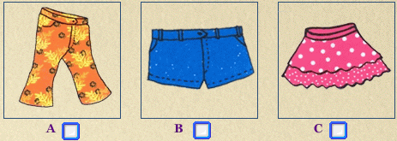  a)A-floral pants B- blue shorts C-polka dot skirt  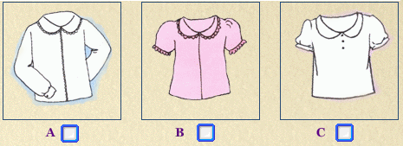  b) A-long-sleeved white blouse  B-short-sleeved pink shirt  C-short-sleeved white shirt  c) A-Sandals B-boots C-brown shoes  New words :  1. announcement ( n ) : thông báo  2. missing = lost ( a ) : thất lạc  3. an entrance ( n ) = door, gate : lối vào  4. fair ( n ) : hội chợ  Questions :  a. How old is Mary ? ( she is three )  b. Where was she last seen? ( she was last seen near the main entrance to the Car Fair )  c. What’s she like? (She has short dark hair).  Tape transcript :  Announcer ( on public Announcement )  Attention please. Here is a special announcement. A little girl is reported missing. She was last seen 20 minutes ago near the main entrance to the Car Fair. Her name’s Mary and she is 3 years old. She has short dark hair. She’s wearing shorts – blue shorts and a long sleeved white blouse. She is wearing a pair of shoes – brown shoes. She may carry a large doll.  If you see Mary, pleasing her to the Information Desk. Her father’s waiting for her there. Thank you.  Feedback:  - B : She’s wearing blue shorts  - A : She’s wearing a long-sleeved white blouse  - C : She ‘s wearing brown shoes  Homework  - Read the tapescript again and try to memorize the content.  - Prepare “Unit 3: Read”

